What elements can I use in a ritual?
Personalise your ritual to what suits you. Don’t worry about what you think you should do, be led by what feels right for you. take a look and see if any or a combination of the ideas below speak to you or inspire you to create your own meaningful rituals;

Smudging
Prayer
Yoga stretches
Journaling
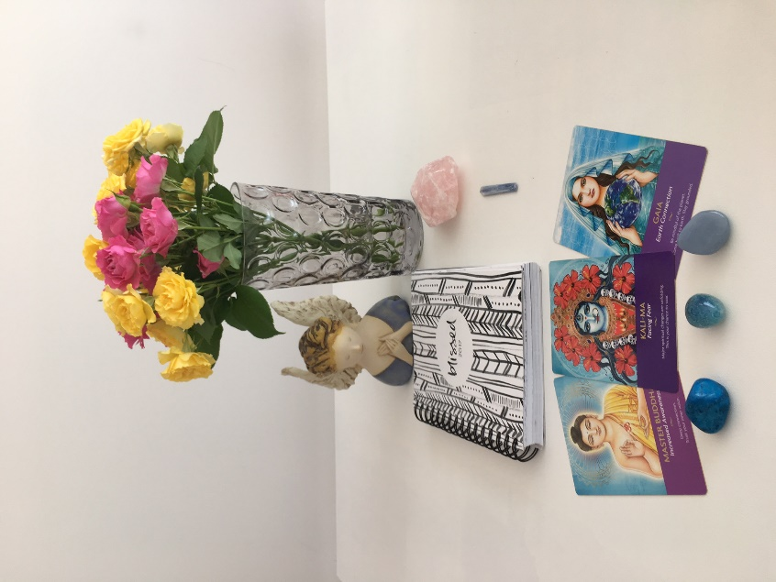

Writing
Meditation
Listening to music
Reading
Listening to a podcast
Affirmations
Gratitude journal
Colouring in
Mindful practice
Lighting a candle or incense
Burning essential oils
Spraying your space with an essential oil blend
Breathing exercises
Grounding – walking on grass

Pulling an oracle card
Set an intention
Chanting or humming
Choosing a crystal for the day

